Analyzing the CO2 Emissions in UK(2005-2019)
And Sectors that are contributing most to Emissions

Sai Goutham Kumar Akula (G01355914)
Department of Data Analytics Engineering
George Mason University
Fairfax, Virginia 22030, USA
sakula7@gmu.edu

Abstract - Environmental problems, such as pollution has been one of the major issues, this happens because of very high consumption of fossil fuels which will result in Carbon dioxide (CO2) emissions, which in turn will lead to climate change, water shortages and soil erosion. In this report a dataset containing the CO2 emissions across United Kingdom(UK) is used to analyse and find the countries that are emitting the most CO2, the sectors and subsector emissions, how emissions changed from 2005 – 2019.

Index Terms – CO2, Emissions, Territorial Emissions, Sectors, Subsectors.

I. Introduction
The world's dependence on fossil fuels has led to increasing levels of carbon dioxide (CO2) emissions. These emissions are a major contributor to climate change, which can lead to a number of problems, including Droughts, Floods, Extreme weather events, Rising sea levels. All of these problems can have a devastating impact on human populations, as well as the natural world. Reducing our reliance on fossil fuels and transitioning to cleaner forms of energy is essential in order to mitigate the effects of climate change. In this report we’ll try to analyse the CO2 emissions across UK to find the countries that are contributing most to emissions. Also we’ll find the sectors and subsectors that are contributing most to emissions, we’ll also find how emissions changed with time and population in period 2005-2019.

Dataset: The data set is selected from GOV.UK website which gives us the CO2 emission statistics from 2005-2019, the dataset includes sectors and subsectors emission data which gives us a scope to find the high emission sectors to plan some measures to reduce CO2[1].

II. RELATED RESEACRH
1. In [2], the authors have analysed CO2 emissions in the road transport sector by using the dataset provided by Irish taxi company and found a model to determine the CO2 emissions by taxis and their impacts. After analysing the data authors found that sharing taxis reduces lot of emissions compared to privately owned vehicles, also authors calculated a intelligent model to study CO2 emissions from taxis and proposed a hybrid unsupervised learning approach to determine the emissions based on the particular structure. This proposed model categorizes taxis with respect to the different features available in taxi and authors found out there are five clusters in the data which are labelled high emitters and concluded that if the manufacturers focus on these five high CO2 emitting features and find the best way possible to mitigate the emissions. This paper mainly focuses only on the road transport sector emissions which is one of the sectors in the selected dataset, but for the selected dataset all different kinds of sectors emissions are provided which gives us the opportunity to find the sector level emissions and broader perspective to factors effecting the CO2 emissions in different industries and sectors. Also, in the selected dataset CO2 emissions can be distinguished by different countries in UK to find the countries emitting the maximum CO2, as a result several adjustments and sanctions can be proposed to mitigate the emissions.

2. In [3], authors briefed on the situation of CO2 emissions in Tianjin a city in China, authors have taken the energy into consideration on how the different types of energy is producing the CO2. According to the data consideration, under the energy structure, coal consumption and coal-fired power generation account for a relatively high proportion. Therefore, we can conclude that the main source of carbon dioxide emissions in Tianjin is coal consumption and coal-fired power generation. Authors also discuss about the rate of the elasticity of CO2 emissions and predicted how much the CO2 emissions may increase for the future years. Also, some solutions to decrease the CO2 emissions were put forward by the authors. While the paper focuses on a specific city in China and discuss about the CO2 emissions based on the energy situation the selected dataset gives us the brief overview of CO2 emissions in the whole country UK and it also have different sectors to consider which gives us more data to handle and provide insights into which country and sectors are the major contributors for the emissions. Also according to the dataset, we can also achieve to find out about territorial emissions which gives us the emissions rate at sub sector level example: The United Kingdom's territorial emissions of carbon dioxide in 2012 were 538.4 million tonnes.

In [4] the authors discussed practical approach to tackle CO2 emissions issue by daily carpooling problem. Carbon dioxide emissions from vehicles are a significant contributor to environmental pollution. In this paper, authors consider the problem of minimizing the total CO2 emissions from a set of vehicles, each traveling between a pair of locations. They focus on the case where the vehicles are operated in a daily carpooling system and develop an integer programming model for this problem. Authors also presented a heuristic solution approach for the problem and reported on computational results for a set of test instances. How much CO2 emissions can be reduced by using the carpooling systems is presented by the authors. In the selected dataset “Domestic” is one of the sectors of which data is provided using which the CO2 emissions by this sector can be determined and one of the effective ways to decrease the emissions of domestic use is by carpooling systems. Also, the rate at which the CO2 emissions is decreased by using carpooling can be calculated by the proposed grouping strategy in the report [3] by the authors.

II. Analyzing Dataset:

The dataset is initially analysed for any missing information and improper formats, the data is cleaned up in the excel to remove all the abnormal data. After clean-up, the data is analysed on how the analysis can be done for the research question and the tools that can be used to produce the visualizations.

- Python: Python is used to analyze and produce the visualizations
- R-Studio: Using R programming the data visualizations can be produced
- My-SQL: Using SQL queries are used to get the average emissions in Countries

III. Visualizations:

- To determine the Country level emissions.
The data is initially imported into the Python by defining the path of the file, then the Pandas, numpy, matplotlib.pyplot libraries are imported. Pandas library is used to import the data and for data analysis. Numpy is used to perform mathematical operations, matplotlib.pyplot is used to create the required plots to visually represent the data.

After the data is imported into Python the data is stored in a data frame and to test the data the first five entries are displayed then using groupby function the countries are grouped and the Territorial emissions are used to get the countries sum of emissions. Using the .plot function the plot is defined as a bar plot and in the plot on x-axis the countries are displayed and on the y-axis the Territorial emissions are displayed.
Each bar represents the sum of all the emissions in ktCO2 by countries in UK from 2005-2019.

From the bar plot(Figure1) created we can easily come to a conclusion that England is the country with more CO2 emissions compared to other countries Scotland, Wales, Northern Ireland all together. All these 3 countries combined only makes up to 20% of the emissions in UK but the other emissions are in the country England. Geographically, England is located closer to the continent than other parts of the UK, and thus may be impacted more by emissions from continental Europe

If we observe the CO2 emissions in England from 2005 – 2019 the emissions are constantly decreased, the main reason for the decrease in CO2 emissions in England between 2005 and 2019 is the switch from coal to natural gas for electricity generation. This switch began in the early 2000s, and by 2019 coal-fired power plants had largely been replaced by natural gas plants. Other reasons for the decrease in emissions include the increase in renewable energy generation and the decrease in overall energy demand. England’s emissions are also affected by the country’s participation in the EU Emissions Trading System, which puts a cap on the amount of emissions that can be released by businesses and industries.[4]

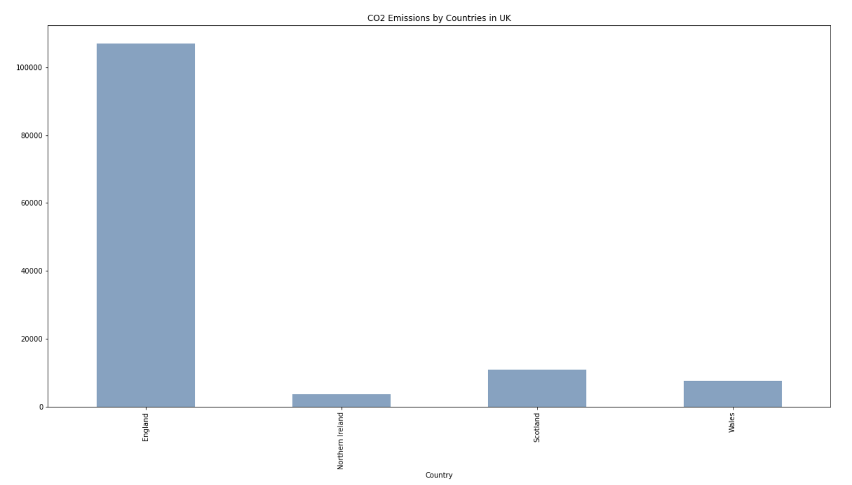
Figure 1

- Emissions within the scope of influence of LAs (kt CO2)
The emissions from a project that fall within the scope of influence of a local authority are those: that the project can be expected to have an impact on the local authority, and that the local authority can be expected to be able to influence.

Finding the emissions within the range of the Local Authorities ais also very important to know the exact localities that are responsible for the maximum emissions, to find this a line chart is created in Python by using the libraries and also plot function. Once the line plot is created it looks like Figure2.

From this we can conclude that the localities in the England country have higher impact on the CO2 emissions in UK, by finding this emissions and analysing we can provide the data about the specifics of the localities to the researchers so they can implement certain measures to reduce the CO2 emissions in that regions which will further decrease the total emissions.

A project may be expected to have an impact on a local authority if it is likely to cause a change in the environmental quality of the area of that local authority. This may be because it will generate emissions of a substance that will be dispersed in the local authority’s area, or because it is likely to lead to a change in the management of waste (which will ultimately result in a change in the volume or composition of waste disposed of to landfill within the local authority’s area).

Emissions may be expected to be within the scope of influence of a local authority if that authority is likely to be able to influence the decisions that lead to their emission. This may be because the authority is responsible for issuing a permit for the project in question, or for approving the plans for the project, or because it is able to exert influence over the emissions from the project once it is operational (for example by controlling how waste from the project is disposed of).

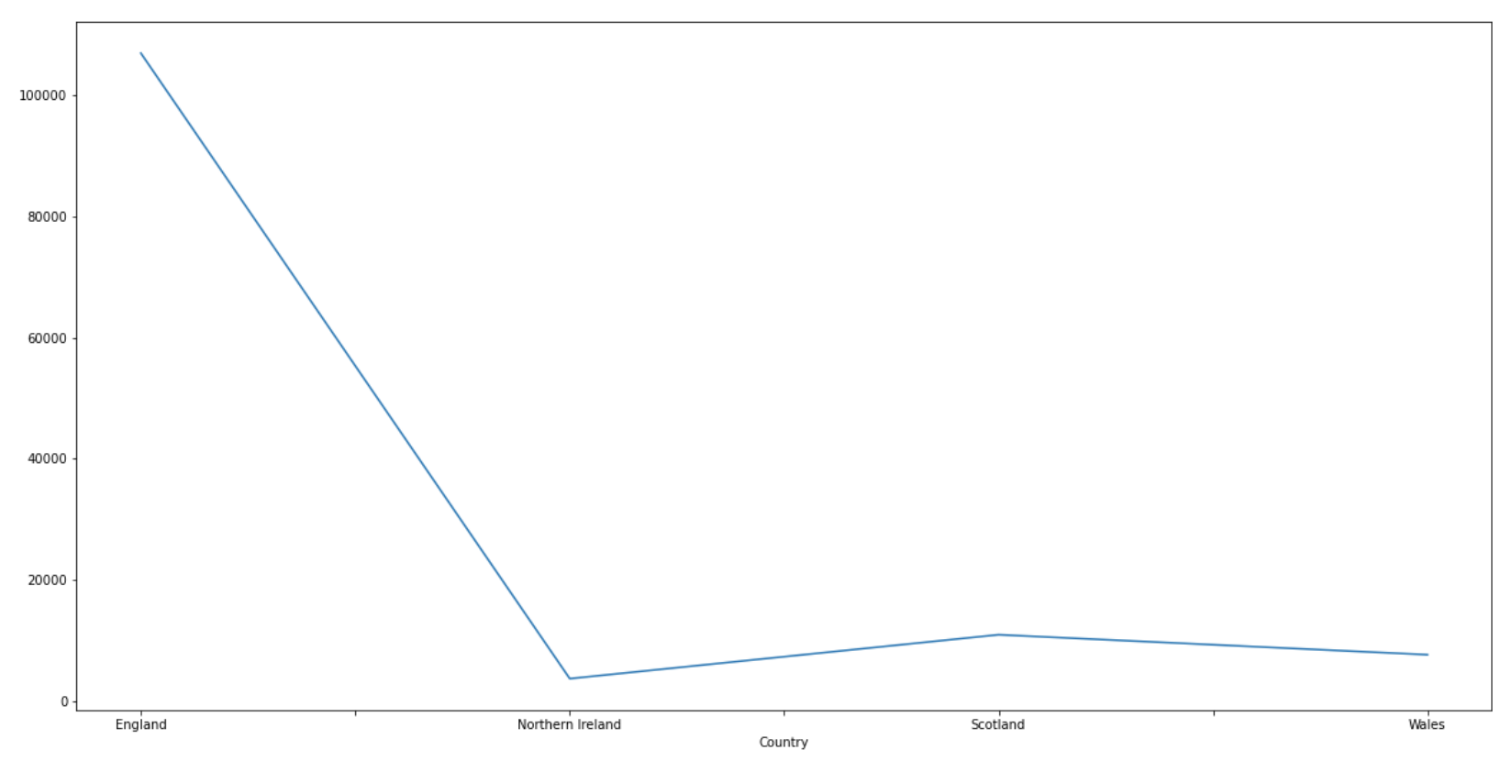
Figure 2
Emissions may be expected to be within the scope of influence of a local authority if that authority is likely to be able to influence the decisions that lead to their emission. This may be because the authority is responsible for issuing a permit for the project in question, or for approving the plans for the project, or because it is able to exert influence over the emissions from the project once it is operational (for example by controlling how waste from the project is disposed of).

As per the line chart we can see the peak is at the England as most of the UK’s population is in England and next to England Scotland has most emissions which is high compared to Northern Ireland and Wales as these countries are similar in land areas and populations. Scotland has more emissions because of the industries that are located which emits most CO2 compares to other 2 countries. Northern Island has the least CO2 emissions.

- Determining the sectors impact on CO2 emissions
The emission in any country can be classified by the sectors of CO2 emissions and There is no definitive answer to this question as the impact of different sectors on CO2 emissions can vary depending on a number of factors, including the specific activities within each sector and the overall efficiency of the sector in reducing emissions. However, a few general trends can be identified.[5]

Generally speaking, the transportation sector is responsible for a large share of CO2 emissions in the United Kingdom, particularly due to the emissions from cars and trucks. The power sector is also a major contributor to emissions, due to the combustion of fossil fuels such as coal and natural gas to generate electricity. Other sectors that contribute significantly to emissions include industry, agriculture, and residential and commercial buildings.

For the visualizations to show the emissions in UK the dataset is imported into the R-Studio using the read.csv function and the libraries used are ‘tidyverse’, ‘ggplot2’ and ‘tidyr’. Once the data is imported all the empty values in the data are removed by using the function na.omit() which will delete all the rows containing NA values.

Once the data is cleaned using ggplot() function aesthetics are defined as X-axis = CO2 Sector, Y-axis = Territorial Emissions and fill is defined as Country, this will define all the columns that needs to be in the visualizations, then geom_bar function is used to create the barplot. Once the barplot is created labels of axis are created using the labs() function. To make the barplot visually appealing colors of the plot are manually changed by using scale_fill_manual() function. Below is the figure 2 which is created using R-Studio which defined the sector wise CO2 emissions and the colors represent the countries.

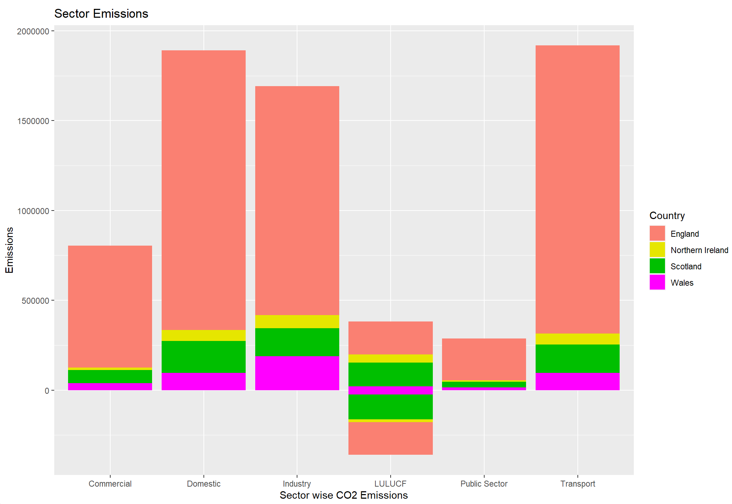
Figure 3
Negative Emissions: Negative emissions CO2 removal is the process of removing carbon dioxide from the atmosphere and sequestering it in a long-term storage repository. This process can be accomplished through a variety of methods, including direct air capture, bioenergy with carbon capture and storage (BECCS), and enhanced weathering.

For the sector Land use, land-use change, and forestry (Lulucf) the emissions show a downward bar in the visualization this is because of the negative emissions which happens because The sector Land use, land-use change, and forestry (Lulucf) is a sink sector, meaning it absorbs more greenhouse gases than it emits. This sector includes activities related to land use, land use change, and forestry. Activities in this sector can result in emissions or removals of greenhouse gases. For example, deforestation can release greenhouse gases into the atmosphere, while planting trees can remove them.[6]

As per the visualization produced, we can see that Transport sector produces maximum CO2 emissions which is followed by domestic and Industry. The transport sector is responsible for about a quarter of all of the European Union’s greenhouse gas emissions. The sector is the second biggest cause of climate change after power generation, according to the European Environment Agency (EEA). This is similar in the case of UK as well and transport is responsible for almost 25% of the emissions.
Domestic sector produces about a seventh of the UK’s total carbon dioxide emissions. Households are responsible for around 27% of the UK’s total carbon dioxide emissions. Heating and powering our homes account for the majority of emissions (82%).

In the plot we can see that stacked bars are produced in which the length of the bars displays the territorial emissions in kt of CO2’s and along different bars displays the information of emissions from different sectors. The different colors in the bar represents different countries.

As shown in the bar plot England constitutes to most of the sector based emissions, so certain reform needs to be taken in England in Transport and Domestic sectors to decrease the CO2 emissions, the measures can include scientific advancements or regulations to stop using certain type of devices which produce high greenhouse gases and CO2. Public transport, walking and cycling are the most sustainable transport modes, but their use is often limited by a lack of infrastructure and by unfavorable conditions which needs to be addressed by the governments to reduce the emissions.[7]

The UK has committed to reducing its emissions of carbon dioxide (CO2) by 80% on 1990 levels by 2050. This target was enshrined in the Climate Change Act 2008, which was passed with cross-party support. The UK was the first country in the world to set legally binding targets for reducing emissions of all six greenhouse gases.
- Determining the Sub-sector level CO2 Emissions

Now that we have concluded about the sector level emissions in UK, we need to focus on the sub sector level emissions to get insights into which sub sectors contribute mostly in the emissions, the main focus needs to be on Transport and Domestic sectors as they are the major contributors to the CO2 emissions.

As seen in above visualization the data and required libraries are imported into R-Studio first and a ggplot is defined with aesthetics as x = CO2 Sub Sectors, y = Territorial Emissions and fill = CO2 sector, after the aesthetics are defined a geom_bar is provided to create a bar plot. Once the bar plot is created using labs function the labels are provided and colors of the bars are changed to make it visually appealing by using scale_fill_manual function. As the subsector names are large a card_flip function is used to flip the axes.

If we observe the bar plot (Figure 3) that is created, in the transport sector almost 70% of the emissions are by ‘Road Transport’ sub-sectors which gives us the major field responsible for the emissions this also gives opportunities for further research which can find the ways to stop or reduce the CO2 emissions by Transport sectors. Electric cars can be used to reduce the emission of harmful pollutants into the atmosphere. Electric vehicles produce zero emissions, which can help to reduce smog and other air pollution. Also, electric cars are more efficient than gas cars, so they use less energy and produce fewer greenhouse gas emissions. There are many strategies that can be employed to reduce emissions from the transport sector. Some are behavioral, some are technological, and some are infrastructural. Based on the location different strategies can be implemented t reduce emissions.

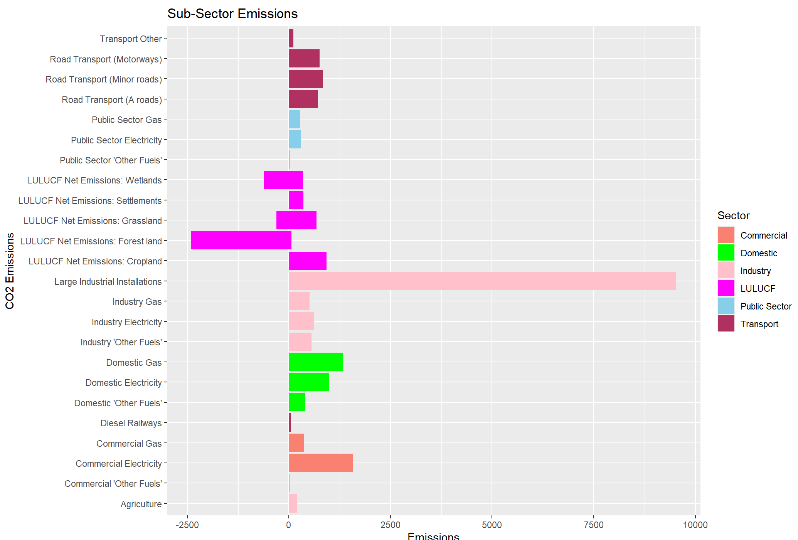
Figure 4

In the Industry sector ‘Large Industrial Installations’ sub sector almost makes up to 80% of the industry sector so we can take measures to get some regulations in place for the Industrial Installations to reduce the emissions from this sector.

Large industry installation emissions of volatile organic compounds (VOCs) are typically controlled using thermal oxidizers, but these systems are energy intensive and expensive, and therefore not an ideal solution for many industries. Catalytic oxidizers are an alternative solution that can provide significant energy and operating cost savings.

In the LULUCF sector we can see that the most negative emissions are observed in Forest Land which clearly states that the forests are main contributors to reduce the emissions, this data can be used to increase the number of forest lands and also make some advancements in the forest field to plant trees that produces Oxygen in large amounts.

UK national emissions of greenhouse gases for the power sector. The power sector includes electricity, combined heat and power (CHP), peat, and coal. The emissions of CHP are included in the electricity emissions figures. UK emissions at a sub-sector level, including emissions from power stations and CHP plants, are shown in the figure below. CHP emissions are shown separately from other electricity generation emissions. The UK's industrial sub-sectors as of 2016, by emissions. Emissions from the paper and board industry totaled around 9.2 million metric tons of CO₂ equivalent that year.

Domestic emissions of greenhouse gases by sector and gas, 1990–2014 from the industrial process and domestic sectors. The industrial sector includes emissions from manufacturing, construction and mining, and from the production and distribution of electricity, heat, gas and water. The domestic sector includes emissions from residential and commercial buildings.[8]

Domestic gas is the subsector which is responsible for most of the domestic emissions which needs to be addressed by the government by giving alternative solutions to the public which will reduce the CO2 emissions.

Overall across all the subsectors the industrial sector accounted for 58% of all UK emissions in 2014, while the domestic sector accounted for 26%. Emissions from the transport sector accounted for 13%, while the agricultural sector accounted for 3%. The majority of the UK's industrial emissions are from the production and distribution of electricity, heat, gas and water, which accounted for 38% of total industrial emissions in 2014. The manufacturing sector accounted for 22% of industrial emissions, while the construction and mining sector accounted for 18%. CO2 emissions needs to be reduced at the sub sector level in order to reach the target of reducing emissions by 80% by 2050.
- Emission changes with time from 2005-2019

As we see in the dataset the emissions are constantly in a downward trend which shows the decrease in the CO2 emissions, This is because of the advancements in the technology in transport and domestic sectors.

After the dataset is imported into R-Studio using gg_plot function aesthetics are defined as x = Year, y = Emissions and fill is given as country to created a stacked bar plot in which different bars represent the emissions of all the years from 2005 – 2019 and the colors in the stack of the bars will represent the countries.

Figure 4 shows that England is the country with maximum emissions throughout all the years and Scotland is in the second place, followed by Wales.

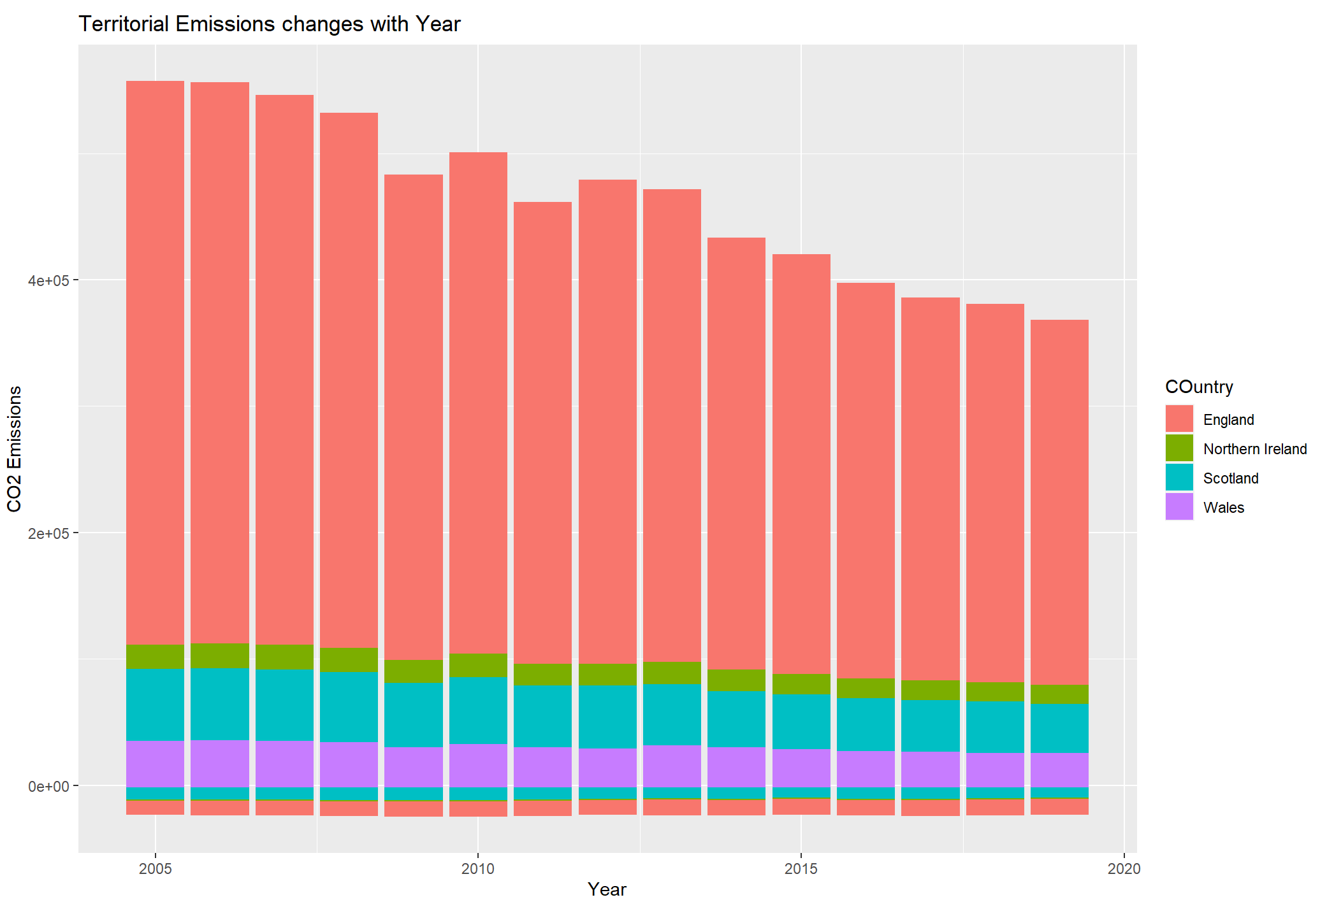

Figure 5

In the United Kingdom, emissions of carbon dioxide in the period from 2005 to 2019 averaged 522.55 million metric tons. The highest volume of CO2 emissions was in 2007, at 548.47 million metric tons. The lowest emission level was in 2018, at 492.39 million metric tons. The industry sector accounted for approximately 23.8 percent of total carbon dioxide emissions in 2019. The industry sector includes manufacturing, mining, and construction, as well as production and distribution of electricity, gas, and steam.[9]

In the United Kingdom, the household sector accounted for approximately 10.9 percent of total carbon dioxide emissions in 2019. The household sector includes residential buildings, such as houses and apartments, as well as all the energy used in these buildings.

- Finding the Average emissions by Countries, Sectors and Sub-sectors

To find the average values of emissions I used SQL(Structured query language) to find the average values, initially to create a schema to store the table used “Create SchemaAIT580” code and once the schema is created a table is created by “create table 2005-19_Local_Authority_CO2_emissions(column name, datatype)” and once the table is created the csv file is them imported using the import table wizard.

Once the table is imported using select command all the table is displayed as below.

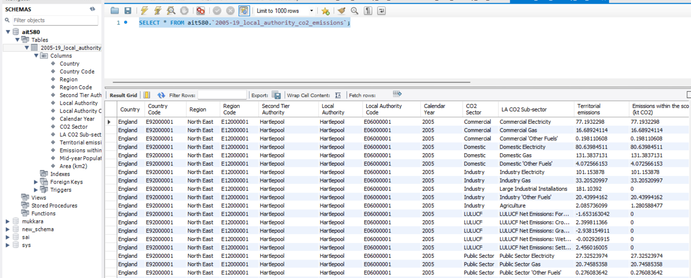
Figure 6
Once the table is successfully displayed then the average of Countries, Sectors, Sub-sectors is queried by using the avg() function which gives the average of the column and then using group by function all the countries, sectors, sub-sectors are grouped. Below is the code used and the result displayed.

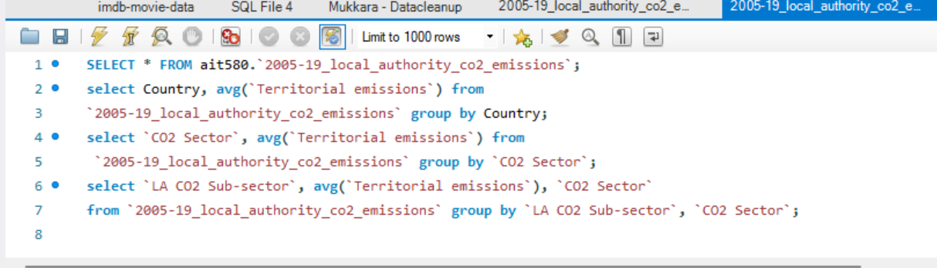
Figure 7

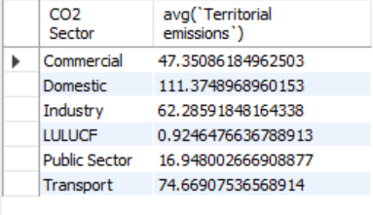
Figure 8

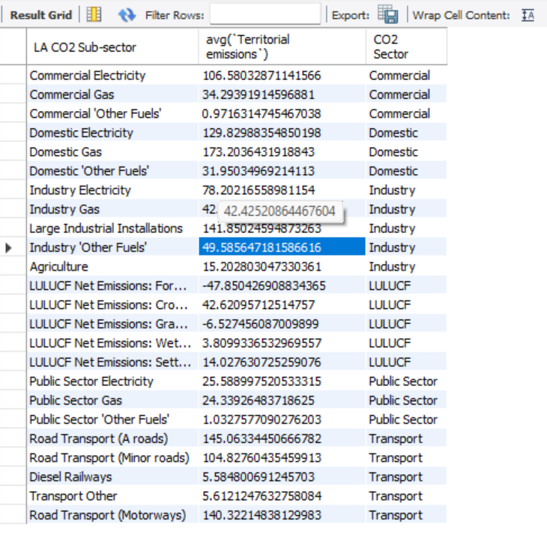
Figure 9
In the figure 6 we can see all the values of the table and in the table 7 we can see the code to find the average of all the required components. Figure 7,8,9 displays the average of emission by countries, sectors and subsectors respectively.

III. Correlation between Emissions and additional factors:

The correlation is found to see how one parameter is effected by the other parameters, in this case correlation factor and plots are created using R-Studio by using cor() function.

In the figure 10 we can see the correlation factor generated for
Territorial emissions and Calendar year, as the value is
-0.04406912 which is closer to 0 and this shows us that there is a weak or no association i.e., with the change in year we can only see there is small change in the emissions.

Figure 10

In the Figure 11 the correlation for Territorial emissions and the Area is found and the value is found to be 0.0190067 which shows that with the change in area there is slight positive correlation to the emissions.

Figure 11
In the figure 12 the correlation for Territorial emissions and the Population is found and the correlation factor is 0.143283 which shows that there is a positive relation between the population and emissions, with the increase in population the emissions increase as domestic emissions is one of the major factors for the overall CO2 emissions.

Figure 12

III. Linear model for emissions and other factors

To find the linearity between two parameters in R programming a linear model needs to be defined between the variables first, using lm() function linear model between emissions and population, area, year is defined and a summary report is generated for the same which can be found in Figure 13.

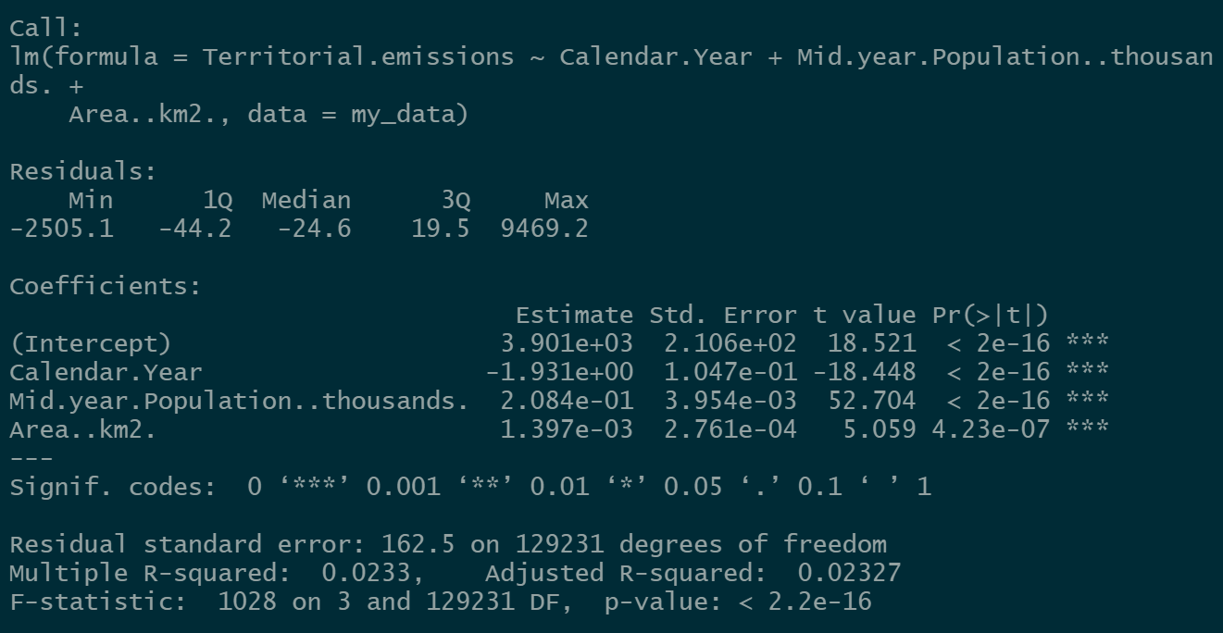
Figure 13

In the above figure we can find the residuals for the territotial emissions and a residual error of 162.5 is found in the created linear model which needs to be resolved. Inorder to resolve the error and decrease the standard error log is introduced in the linear model which decreased the error to 2.088. This means the linear model is created with very small error and we find that the linearilty is satisfied for this model and the summary statistics are shown in figure 14. Linear model created is shown below in Figure 15.
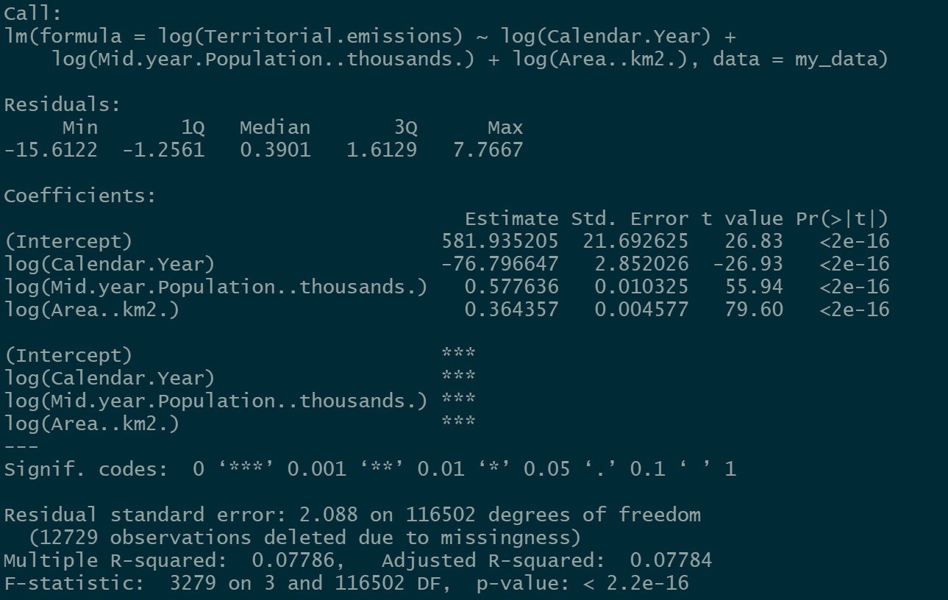
Figure 14
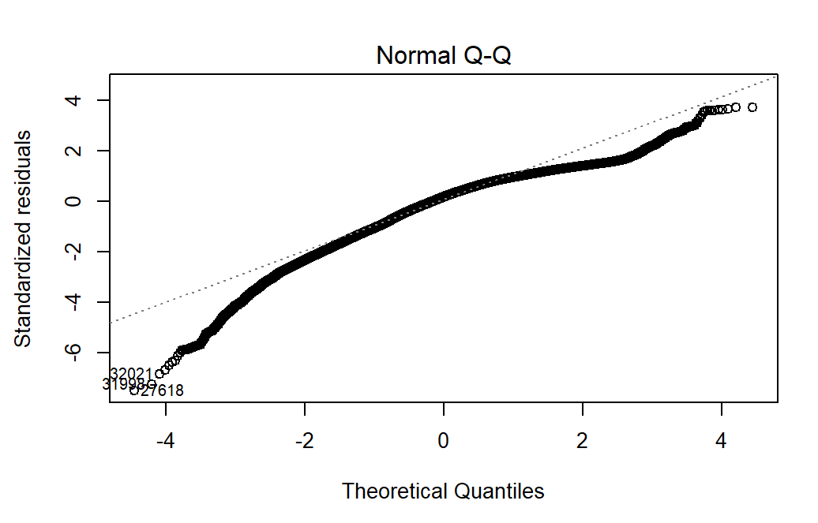
Figure 15
In the linear model created a cluster is found with some of the outliers which needs to addressed further.

IV. Future Research

There is a great deal of research that still needs to be done in order to fully understand the potential future impacts of rising CO2 emissions. In particular, more research is needed to understand how rising CO2 emissions may impact regional climates, as well as the potential for feedback loops that could amplify the effects of climate change. Additionally, further research is needed to assess the potential impacts of climate change on human health, food security, and water resources.

As seen in the dataset and visualizations throughout the report, in UK England is the country with maximum emmisions becuase of the area and population and also Transport, Domestic sectors are found to be the major emitters of CO2. This problem needs to be addressed with further research on how to decease the emissions in these sectors majorly which will have a very high impact on the emissions. Future research has a very large scope in addressing the problems in Transportation sector and use of electric vehicles and domestic gas usage.[10]

V. Conclusion

To conclude, we can observe the CO2 emissions in UK is already in a downward trend from 2005-2019 which is a good thing and further we found the sectors and subsectors that are mostly responsible for mximum emissions which can be confined by making technological advancements after future research. The governments across the world need to take emissions problem as a priority which needs to be resolved to avoid further damage to the environment. The government should also encourage the industries to reduce their waste. The industries should be encouraged to recycle their waste. The government should also provide subsidies to the industries which are recycling their waste. The government should also bring in regulations to limit the CO2 emissions.

Glossary
- Emissions: the production and discharge of something, especially gas or radiation.
- LULUCF: Land use, land-use change, and forestry
- Sectors & sub sectors:Industries that produce CO2
- SQL: Strustured Query Language
- EEA: European Environment Agency
- CHP: Combined Heat and Power
References
[1]Emissions of air pollutants. (2022, February 18). GOV.UK. https://www.gov.uk/government/statistics/emissions-of-air-pollutants

[2]Ghahramani, M., & Pilla, F. (2021). Analysis of Carbon Dioxide Emissions From Road Transport Using Taxi Trips. IEEE Access, 9, 98573–98580. https://doi.org/10.1109/access.2021.3096279

[3] Y. Xie, J. Pang and X. Feng, "Research about CO2 Emission under the Current Energy Structure in Tianjin," 2010 International Conference on E-Product E-Service and E-Entertainment, 2010, pp. 1-4, doi: 10.1109/ICEEE.2010.5660365.
[4] Bruck, B. P., Incerti, V., Iori, M., & Vignoli, M. (2017). Minimizing CO2 emissions in a practical daily carpooling problem. Computers & Operations Research, 81, 40–50. https://doi.org/10.1016/j.cor.2016.12.003

[5] Department for Business, Energy & Industrial Strategy. (2021, June 24). UK local authority and regional carbon dioxide emissions national statistics. GOV.UK. https://www.gov.uk/government/collections/uk-local-authority-and-regional-carbon-dioxide-emission

[6] Statista. (2022, March 24). Greenhouse gas emissions in the UK 1990–2020. https://www.statista.com/statistics/326902/greenhouse-gas-emissions-in-the-united-kingdom-uk/

[7] Harrisson, T. (2019, February 4). Analysis: Why the UK’s CO2 emissions have fallen 38% since 1990. Carbon Brief. https://www.carbonbrief.org/analysis-why-the-uks-co2-emissions-have-fallen-38-since-1990

[8] Lin, B., & Xie, C. (2014). Reduction potential of CO2 emissions in China׳s transport industry. Renewable and Sustainable Energy Reviews, 33, 689–700. https://doi.org/10.1016/j.rser.2014.02.017

[9] Santos, G. (2017). Road transport and CO 2 emissions: What are the challenges? Transport Policy, 59, 71–74. https://doi.org/10.1016/j.tranpol.2017.06.007

[10] Kesicki, F. (2012). Costs and potentials of reducing CO2 emissions in the UK domestic stock from a systems perspective. Energy and Buildings, 51, 203–211. https://doi.org/10.1016/j.enbuild.2012.05.013

